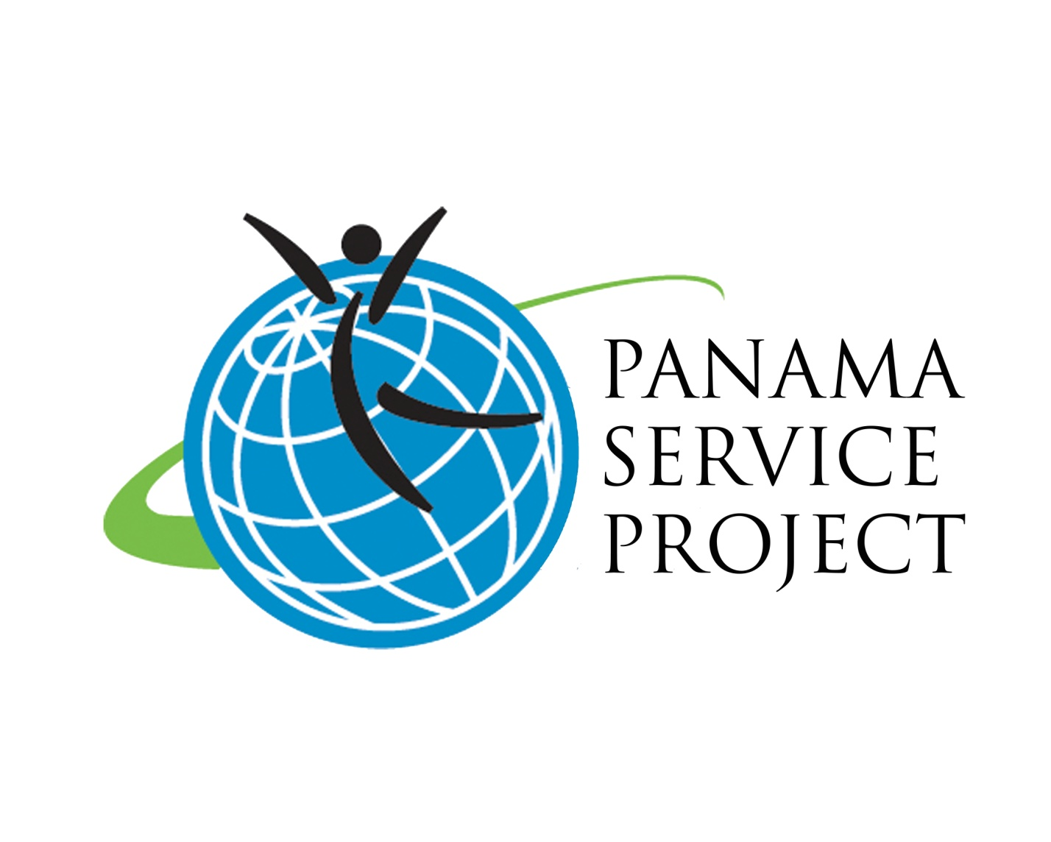

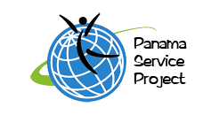

, LLC

Bridging the Gap between Cultures

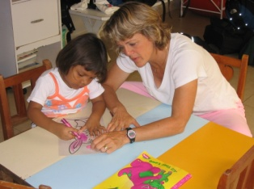

Program Handbook

In conjunction with *Friends of Nutre Hogar*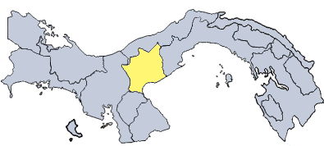[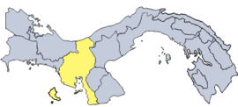](http://en.wikipedia.org/wiki/Image:Veraguas.png)

Founded in 2005, the Panama Service Project, LLC is an organization dedicated to helping people gain an understanding of cultures other than their own through a service learning and immersion experience in Panama. We work with Nutre Hogar, a nonprofit, non-governmental organization in Panama that restores malnourished and starving children to health and educates the parents about health and nutrition.

Before traveling:

We recommend reviewing the following sections:

* Passport information
* Insurance
* What to Bring
* Program Policies

**Contact information for Panama Service Project, LLC:**

**Holly Morse, Director**

7630 Boyd Way

Milwaukee, WI 53217

(414) 588-3501

holly@panamaserviceproject.com

**Jenny Morse, Program Administrator**

(720) 254-8161

[jenny@panamaserviceproject.com](mailto:jenny@panamaserviceproject.com)

Website:

[www.panamaserviceproject.com](http://www.panamaserviceproject.com)

*(Friends of Nutre Hogar information can be found on:* [www.friendsofnutrehogar.com](http://www.friendsofnutrehogar.com))

1. **Program Policies**
   1. Policy on Drinking

Alcohol consumption by minors is strictly FORBIDDEN on the trip. Participants who are found drinking will be sent home at their parent’s expense. The legal drinking age in Panama is 18, but any participant under 21 must adhere to the drinking age policy in the U.S. that forbids drinking under 21 years of age.

* 1. Policy on Drugs

Drug use of any kind is strictly FORBIDDEN on the trip. Participants who are found using or under the influence of drugs will be sent home at their parent’s expense.

1. **Financial Information**
   1. Program Fees

The program includes the following:

* Round trip international airfare including taxes and all bus transportation in Panama.
* 24-hour emergency support.
* Comprehensive emergency medi-vac insurance.
* Orientation materials including vocabulary lists, Panama education manual and travel tips.
* Host family accommodations and meals for the duration of the stay in the host community.
* All program-related expenses for one school Group Leader from 6-10 participants. For 10-20 participants, another group leader will also receive all program-related expenses.
* Five or fewer participants, a Group Leader will receive a 15% discount per participant.
* Pre-trip organizational meeting for all participants.
* Pre-trip acculturation meeting for all participants.
  1. Payment Schedule
     1. Panama Service Project, LLC requires three payments from the participant:
        1. $125 due with application by December 1st. Initial payment includes a $25 non-refundable fee (application fee will be applied to the program fee for accepted applicants) with $100 deposit (the deposit will be returned in the event that the student is not accepted). **All application materials are available at** [**www.panamaserviceproject.com**](http://www.panamaserviceproject.com)**. Completed materials should be submitted to your teacher or chaperone. If you are an independent student, submit application materials to the program director. Successful applicants will be notified to proceed with registration on the program site.**
        2. January 15, 50% of remaining trip cost per student.
        3. May 15, final payment of program fee balance.
     2. Payments are preferred via checks made out to ***Panama Service Project, LLC*** may be mailed to ***7630 Boyd Way, Milwaukee, WI 53217***. Payments may also be made online.
  2. Late Applications
     1. Late applications may be accepted after Dec 1st.
     2. Any student who adds to the group after Dec 1st will pay a $100 late fee *plus* any additional airfare and/or administrative costs.
     3. Upon late enrollment, the 1st, 2nd, and late fee payments will be due plus all relevant information requested by the Group Leader.
     4. No registrant will be considered an official participant until submitting all required registration materials and full payment.
  3. Cancellation Policy

**All cancellations must be confirmed IN WRITING and sent to the Group Leader, who will then forward it to the Panama Service Project Program Administrator. No refund will be issued without written notification.**

* + 1. **Cancellations between the Program Deposit Deadline (Dec. 1) and the Final Payment Deadline (May 15):** If you cancel during this time, you will be assessed a $250 cancellation fee. In addition to the $250 cancellation fee, you may also be required to pay an airline cancellation fee and any side trip, insurance, administrative or other expenses not refundable to Panama Service Project, LLC at the time of cancellation.
    2. **Cancellation between the Final Payment Deadline (May 15) and the Day of Departure:** In addition to the $250 fee, participants canceling during this period will be required to pay any airline cancellation fees and any side trip, insurance, administrative or other expenses not refundable to Panama Service Project, LLC at the time of the cancellation. Any monies to be refunded to participants will be calculated at this time and be sent by check directly to the participant. Cancellation during this period could result in the loss of the total program fee.

Please note that Panama Service Project, LLC makes every effort to obtain refunds for participants. All monies which are recoverable, except for cancellation fees and other expenses incurred by Panama Service Project, LLC will be refunded. In the event a participant cannot participate due to poor behavior or grades, it is the Group Leader’s responsibility to decide how the participant will be reimbursed.

1. **Insurance**

There are three ways in which participants are covered by insurance while in Panama:

* All Panama Service Project, LLC participants must be covered under their parents’/guardians’ medical insurance and are asked to show proof of medical insurance coverage with registration.
* Panama Service Project, LLC provides major emergency medical and life-threatening evacuation insurance through Assurant Health and administered by IMG. The policy coverage is not designed to be in lieu of U.S. major medical insurance, rather, it is a limited secondary policy obtained to cover critical emergency in-country hospitalization, doctors’ fees and treatment charges and evacuation costs in the event of a medical emergency. The policy also includes coverage up to $15,000 for emergency reunion costs in the event a parent needs to come to Panama. The cost of this insurance coverage is included in the established program price.
* Panama offers free tourist insurance for 30 days upon entering the country. This insurance covers most incidents of illness and accident that may occur while traveling in the country. Panama has excellent medical care and quality treatment for routine problems is readily available.

NOTE: Routine treatment in Panama is typically inexpensive. Any treatment not covered by the three policies listed above will be paid by or charged to the participant to avoid charging all participants for such contingencies.

1. **Passport Information**

Passports are required for participation in the Panama Service Project. U.S. citizens may obtain passports from U.S. Passport Agencies located in major U.S. cities, as well as from any County Clerk’s office or from certain post offices. To obtain a passport, you must submit the following items along with a completed passport application form which you can obtain from the post office.

* **Evidence of U.S. Citizenship:** certified birth certificate, naturalization papers or previous passport.
* **Identification:** in the form of a document bearing your description or photograph and signature, such as a driver’s license.
* **Two duplicate front**-**view photographs (full face):** 2” square and taken within the previous six months.
* **Fee**: as specified on application; payable by check or money order.

Passport info is conveniently located on the Department of State web site: <http://travel.state.gov/passport_services.html> or call the National Passport Information Center at 1-888-362-8668 (There is a charge for calling).

**Passports may be obtained collectively or individually. You should apply for them as soon as possible because procedures may take months due to backlog.**

During the trip, students will be responsible for their own passports. When we are staying in hotels, passports and other valuables may be locked in hotel safes. When we are staying in homes with families, passports may be kept safely in suitcases. Students may be required to bring passports on particular excursions like the Panama Canal and gira, which require ID.

1. **What to Bring Abroad**
   1. **The following must be carried by all participants:**

* Orientation materials (phone lists, vocabulary lists, etc.)
* Luggage tags
* Passport (It is very important that the passport be kept in a secure place. It is **mandatory** that we have a copy of the passport on file along with application materials.)
* Student ID—required for Panama Canal
  1. **Packing, Gifts, and Spending Money**
     1. **Packing**

A packing list will be given to all participants in May. Please keep in mind that people dress conservatively in Panama and a bit more formally than we do. Girls should wear shorts longer than mid-thigh; capris are better. Everyone will need pants (knee-length dresses or skirts are acceptable), shirts with collars and sleeves, and one pair of closed-toe dress shoes.

Students should bring 1) a carry-on backpack with emergency overnight items in case bags are delayed, 2) a checked bag weighing no more than 50lbs, 3) a duffle bag for donations—most students will check two bags down, one filled with donations and paid for by Nutre Hogar. If a student does not have a duffle, one can be provided. Students usually check only one bag on return, including souvenirs. If a student needs an extra bag on return, s/he will have to pay for those fees.

* + 1. **Suggested Gifts**

Gifts should be lightweight, simple, inexpensive and as much as possible, representative of your community, home or region. Avoid fragile items. Picture frames (in which you can place a picture of you with your host family at the end of the stay), CDs of favorite music, small picture albums, baseball caps, team jerseys and t-shirts are all suggestions.

* + 1. **Spending Money**

Participants are urged to carry an ATM card (call bank in advance to let them know you will be traveling to Panama). We also suggest that the participant bring $300 (American Dollars are used in Panama) in spending money for personal expenses, although some people spend more for shopping. Participants will need to budget their money, though the cost of living in Panama is much lower than in the U.S.

d. **Donations**

Typically, we collect diapers, Children’s Tylenol, formula, baby toothbrushes, toothpaste, crib sheets, plastic plates and cups, and latex gloves.

1. **Immunizations**

No special immunizations are needed, but we highly recommend that you speak with your doctor to follow their recommendations and do what is most comfortable for each individual family.

**Thank you for participating in the** *Panama Service Project* **program!!!**

Teachers with Students:

How to participate in the Panama Service Project:

* 1. Announce trip dates and information to students by middle of October.
  2. Attend informational meeting in November at The Town Club in Fox Point for Milwaukee-area schools.
  3. Hold interviews or complete application process (whichever you prefer—our application materials are available online) and select participants. Your students’ first payment is due Dec 1st.
  4. After you select students, notify the Administrator to receive the Registration password. Send Registration password to students.
  5. Plan and hold your own school fundraising activities to raise money and donations for Nutre Hogar.
  6. First deposit of 50% of remaining program fee due January 15th. Send checks made out to “Panama Service Project, LLC” to 7630 Boyd Way, Milwaukee, WI 53217 or pay online.
  7. Have students attend May culture workshop to help acclimate to Panamanian culture differences and to learn a little about Panama, the indigenous populations and the Canal.
  8. Help students complete Registration by March 1st, using password emailed in December.
  9. Remainder of program fee due May 15th. Send checks made out to “Panama Service Project, LLC” to 7630 Boyd Way, Milwaukee, WI 53217 or pay online.
  10. Attend May meeting to go over packing lists, gift ideas and answer questions.
  11. Receive homestay information by the beginning of July.
  12. Depart for Panama!

Individual Students:

How to participate in the Panama Service Project:

1. Attend informational meeting in November at The Town Club in Fox Point for Milwaukee-area participants.

2. Apply by Dec 1st for admission ([www.panamaserviceproject.com](http://www.panamaserviceproject.com)). Complete application forms and submit $25 non-refundable fee and $100 deposit. Download application materials and submit to your teacher or chaperone. If you are an independent student, submit documents to Program Director, Holly Morse.

3. Receive acceptance notification no later than Dec 15th and password for Registration.

4. Review Registration requirements at [www.panamaserviceproject.com/registration](http://www.panamaserviceproject.com/registration) using emailed password and complete it by March 1st.

5. Plan and hold your own school fundraising activities to raise money and donations for Nutre Hogar.

6. First deposit of 50% of remaining program fee due January 15th. Send checks made out to “Panama Service Project, LLC” to 7630 Boyd Way, Milwaukee, WI 53217 or pay online.

7. Attend May culture workshop to help acclimate to Panamanian culture differences, and to learn a little about Panama, the indigenous populations and the Canal.

8. Remainder of program fee due May 15th. Send checks made out to “Panama Service Project, LLC” to 7630 Boyd Way, Milwaukee, WI 53217 or pay online.

8. Attend May meeting to go over packing lists, gift ideas and answer questions.

9. Receive homestay information by the beginning of July.

1. Depart for Panama!